|  |
| --- |
| **Team ID :** LTVIP2025TMID58715 |
| **Project Name :** OrderOnTheGo: Your On-Demand Food Ordering Solution |

**Create database in cloud**

• Install Mongoose.

• Create database connection.

Reference Article: <https://www.mongodb.com/docs/atlas/tutorial/connect-to-your-cluster/>

Reference Image:

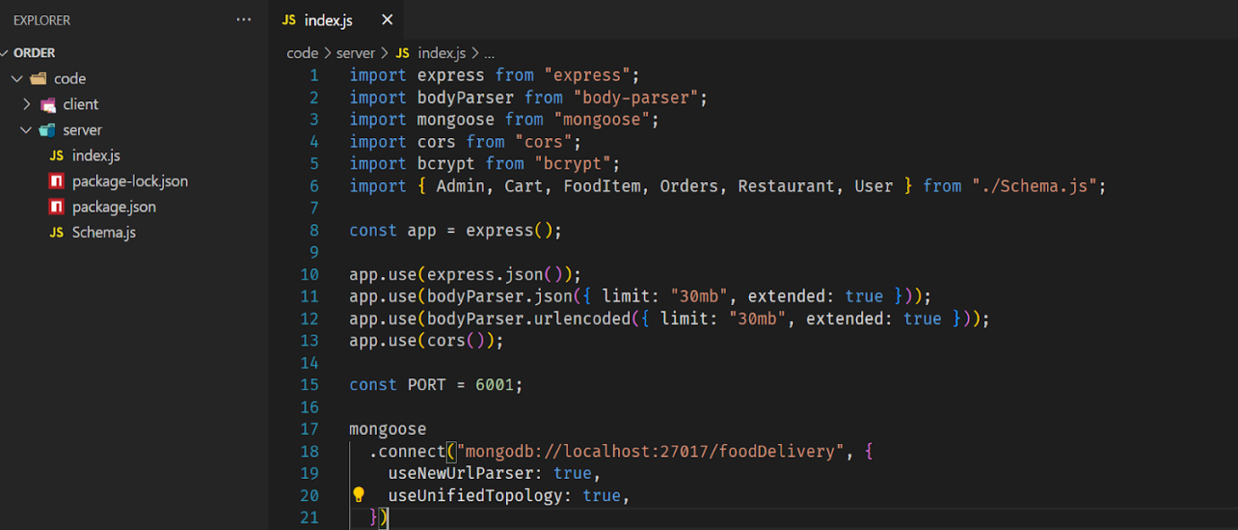

**Database Development**

**Schema use-case:**

**1. User Schema:**

• Schema: userSchema

• Model: ‘User’

• The User schema represents the user data and includes fields such as username, email, and password.

**2. Product Schema:**

• Schema: productSchema

• Model: ‘Product’

• The Product schema represents the data of all the products in the platform.

• It is used to store information about the product details, which will later be useful for  ordering.

**3. Orders Schema:**

• Schema: ordersSchema

• Model: ‘Orders’

• The Orders schema represents the orders data and includes fields such as userId,  product Id, product name, quantity, size, order date, etc.,

**4. Cart Schema:**

• Schema: cartSchema

• Model: ‘Cart’

• The Cart schema represents the cart data and includes fields such as userId, product  Id, product name, quantity, size, order date, etc.,

• The user Id field is a reference to the user who has the product in cart.

**5. Admin Schema:**

• Schema: adminSchema

• Model: ‘Admin’

• The admin schema has essential data such as categories, promoted restaurants, etc.,

**6. Restaurant Schema:**

• Schema: restaurantSchema

• Model: ‘Restaurant’

• The restaurant schema has the info about the restaurant and it’s menu

**Schemas:** Now let us define the required schemas

